ClubRunner
Club communication made easy

Getting Started

Finding Out Your Username and Password

Go to your club website. Click on the Login tab, located at the top of the page, as well as the right hand side of the homepage. Click on the “Forgot Your Password?” link.

This will take you to the “Get Password” screen.

You will be asked to enter your last name and your email address, and then click on the “Get Login Info” button. You should receive an email with your login information shortly.

Please note that the last name and email address you provide must match what is on record for security purposes. If you are unable to get your password, ClubRunner Support at support@clubrunner.ca with your name and club and it will be emailed to you, or contact your club Internet director.

Login to your Club Website

Start at your club home page. To login, click on the Login tab located at the top of page, or click on the Login link at the top right of the Home page.

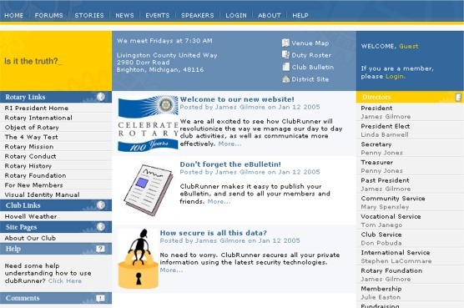
Home Page

This will take you to the Member Login page. Enter your login name and password in the appropriate fields and click on the Login button. If your login has been successful, you will be directed to the Admin page. You should see your name at the top right.

The Admin tab is a members only page where you will go to contribute to the site, email your members, change your profile, and much more.

If you have trouble logging in
This may be due to an invalid password or login name. Try to copy and paste your login name from the email you receive to ensure accuracy. If you still cannot get into the system, email support@clubrunner.ca with your login name and password and you will get a new password assigned.

Editing Your Profile

Next you will check your member profile. This step is vital if you want to receive all email correspondence.

- Click on the Admin tab.
- Click on Edit My Profile, where you will see all your information.
- Fill in as many details as you need. The email address is the most important piece of information to include.
- Click on Save, located at the bottom of the page.

This guide is an excerpt of the extensive online help available on your website. To access the online help, click on the Help tab at the top of your homepage.

For future reference, record your login information below.

Login name:
Password:

Your club website is located at:
https://flintrotary.org/

